Lab-Project 3: Identifying File Types
Course Name: FRS301-Digital Forensics
Student Name: Nguyễn Trần Vinh – SE160258
Instructor Name: Lê Tiến Dũng
Lab Due Date: 31/1/2023

Purpose
To practice identifying unknown file types.
Getting the Files
Download the 7-zip archive: text.7z (or Lab-Proj.03_text.7z form the instructor)
Open it with 7-zip. If you don't have 7-zip, you can get it here:
http://www.7-zip.org/
When the files are extracted, you should see a folder with six files, like this:
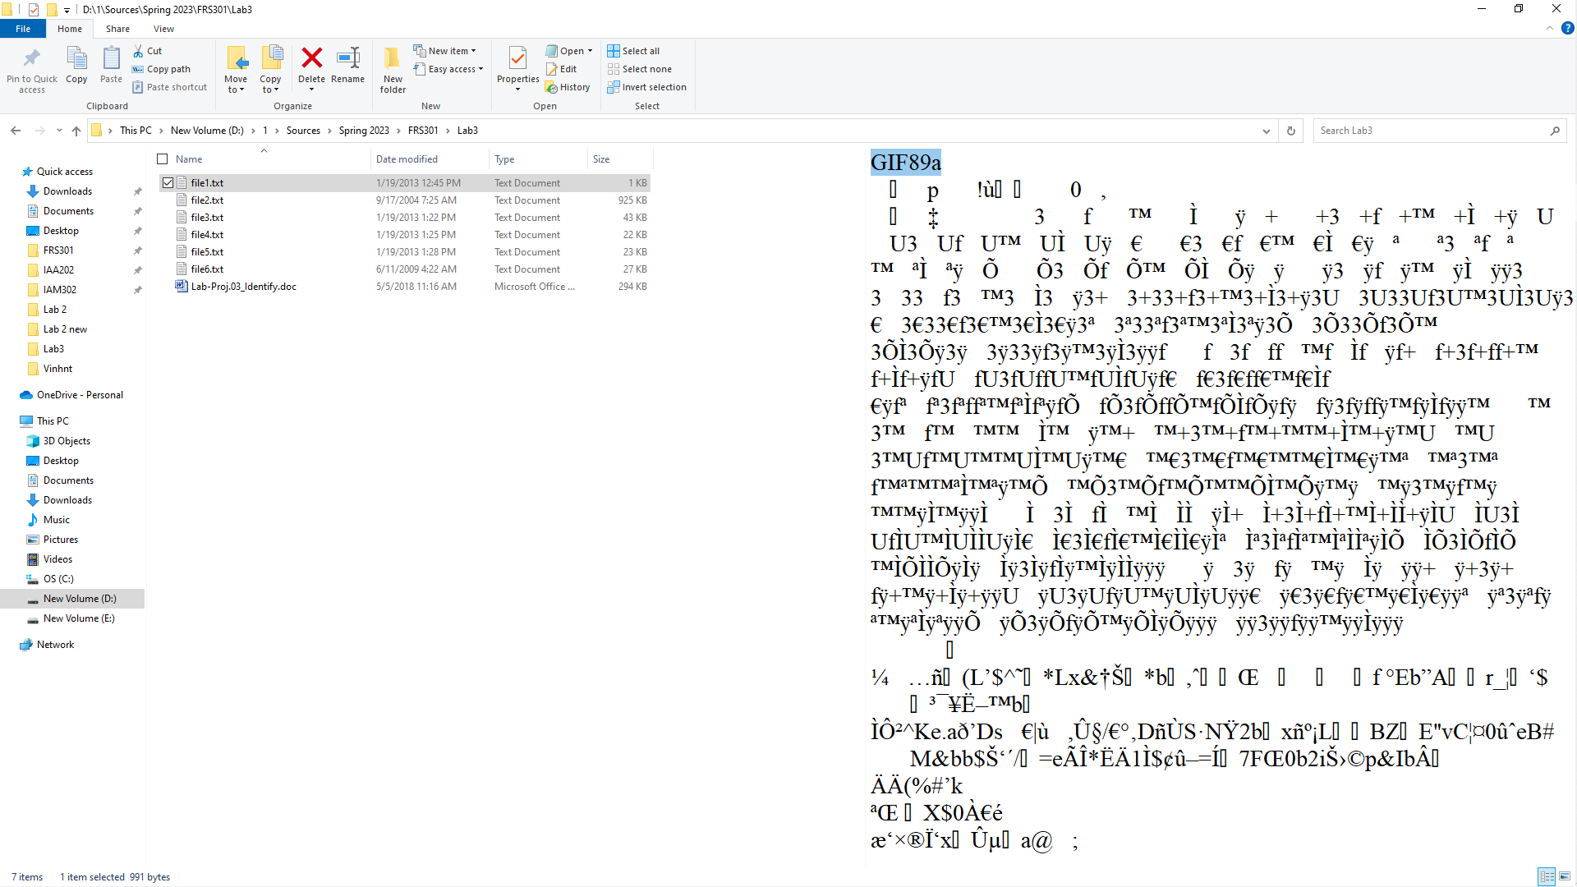
Goal
Your goal is to determine the correct file type and therefore the correct file extension for each file. Right now they all have .TXT extensions, but none of them are actually TXT files.
Procedure
You can do it any way you like. The technique I demonstrated in class was to use Notepad in Windows.
The first file is the one I used for a demonstration in class, so it's not worth any points.
Here's how to solve the first one.
Double-click file1.txt to open it in Notepad.
Although most of the file is unreadable binary, the first few characters are readable ASCII: GIF89a
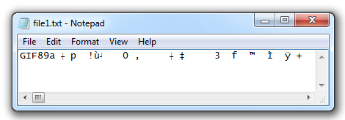
You may remember from lecture that this is a GIF file. If you don't remember, just Google "GIF89a" and you will find that the correct file extension is .GIF
Then double-click the file to open it in a program appropriate to its real type:
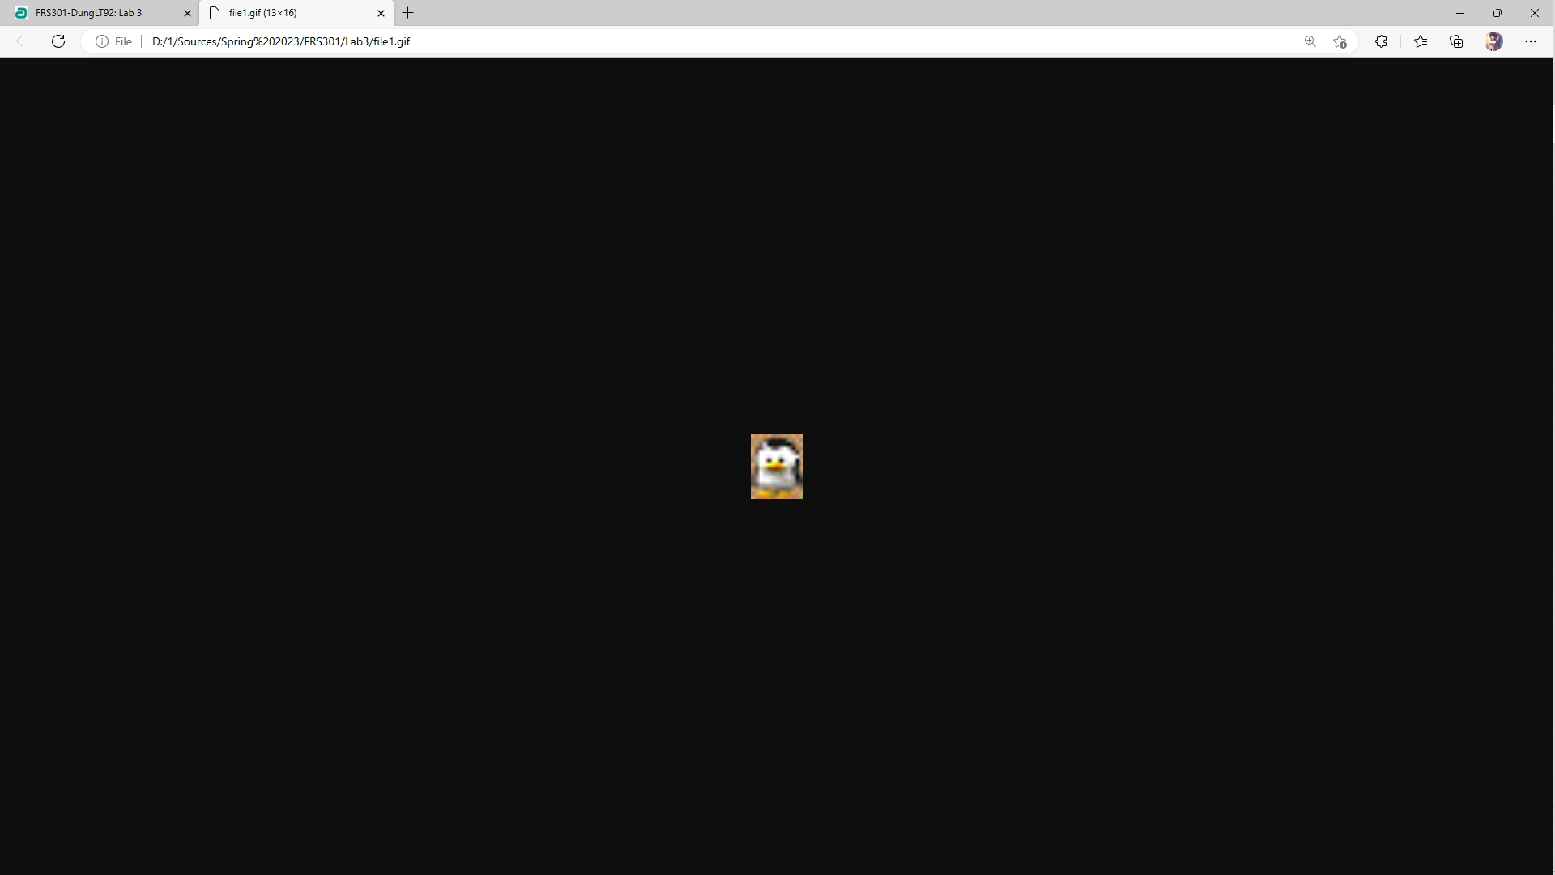
As you can see, the file is a recognizable image of a penguin. It opened in Internet Explorer on my system.
When you get the extension correct, each of these files will open to create a recognizable, useful document.
Use the same procedure to find each extension, as summarized below:
- Open the file in Notepad
- Find some readable text at or near the beginning of the document
- Google the readable text to find out what file type it is and what filename extension to use
- Change the filename extension to the correct one
- Open the file in its proper application and verify that it becomes a recognizable document. You may have to locate and install an appropriate application.
Turning in Your Project
There are no images to capture. Just send an email to xxx@fe.edu.vn with a subject line of "Lab-Proj 3 from YOUR NAME".
In the body of the email, give the correct filename extensions for each file like this (using the correct extensions, not TXT)
File2.exe
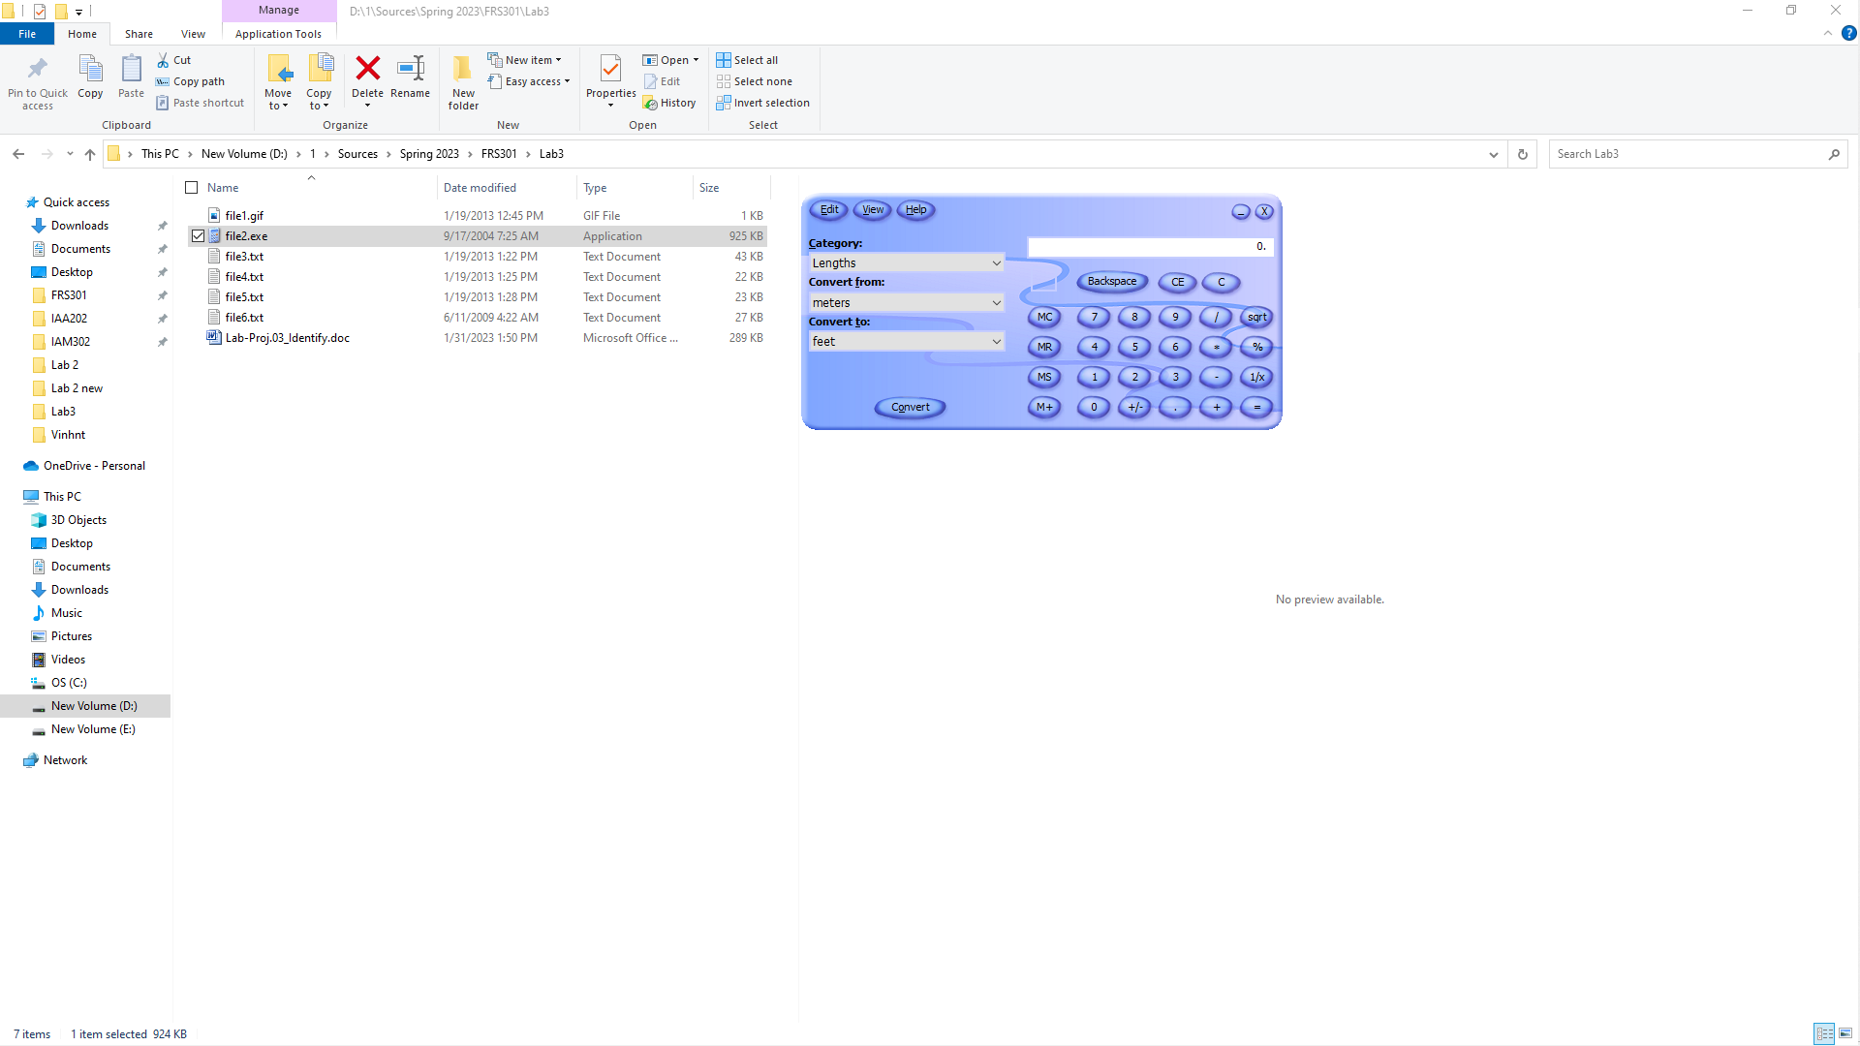
File3.pdf
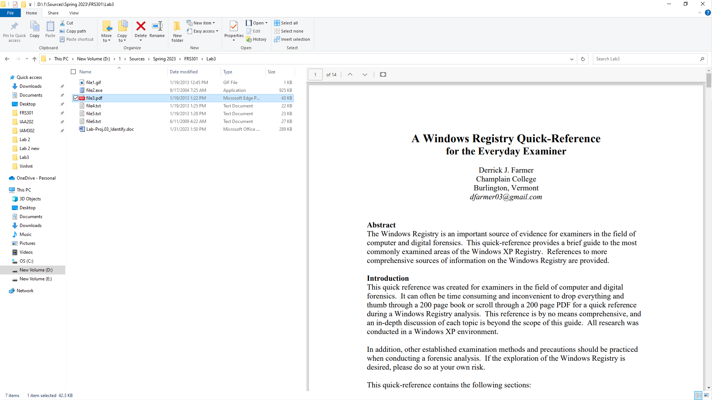
File4.doc
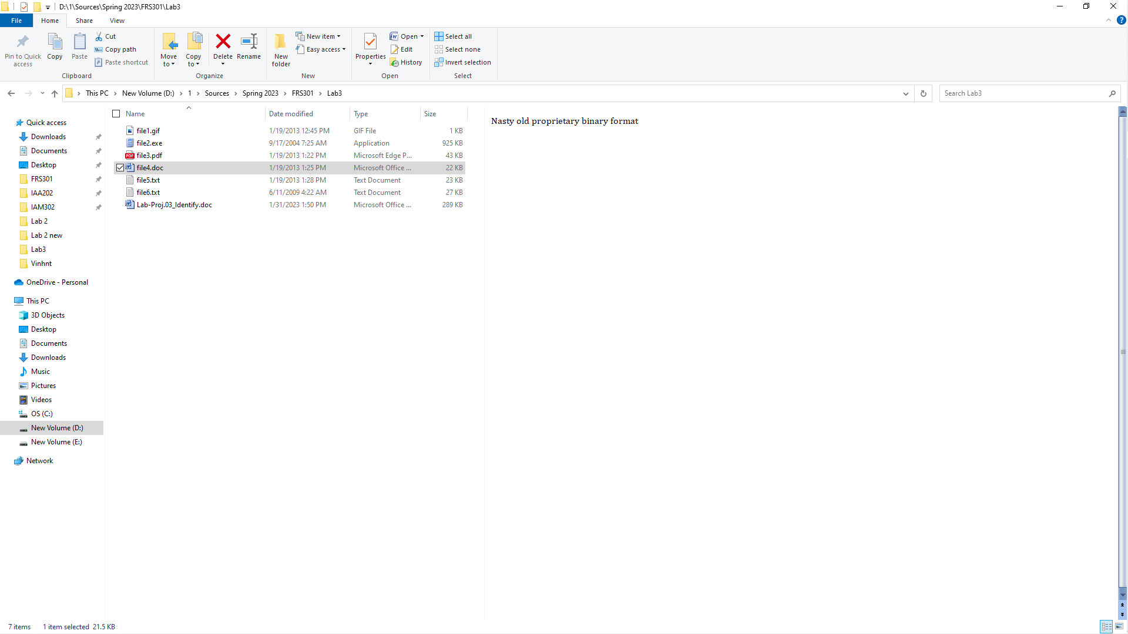
File5.jfif
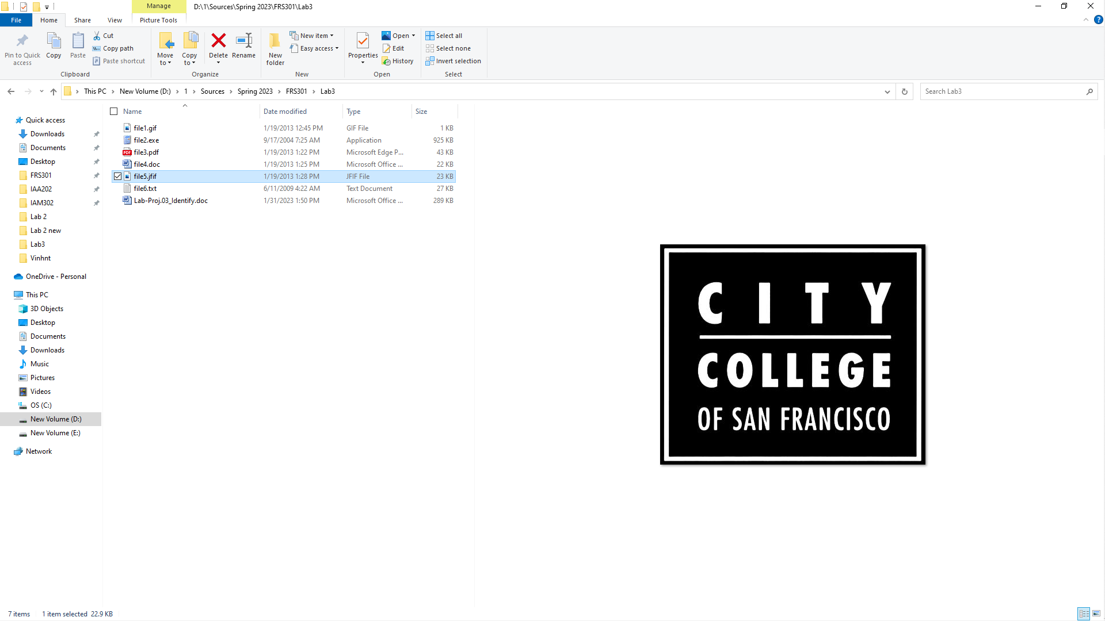
File6.wav
